Q1. Calculate the following aggregate metrics:
- Total Transactions
- Total Customers
- 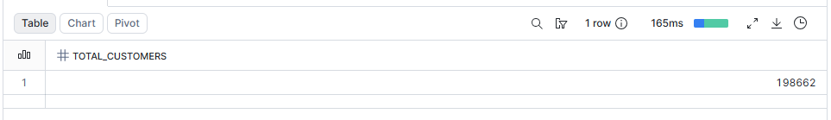
- Total Fraud Transactions
- 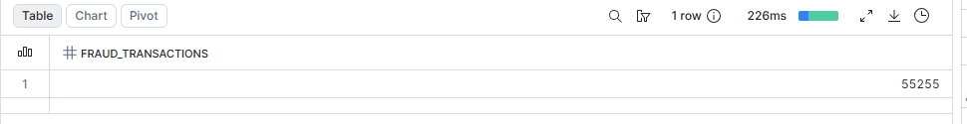
- Fraud Percentage
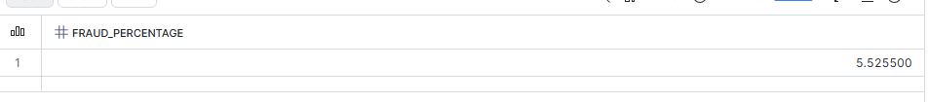
Q2. Find the top 10 countries by transaction volume.
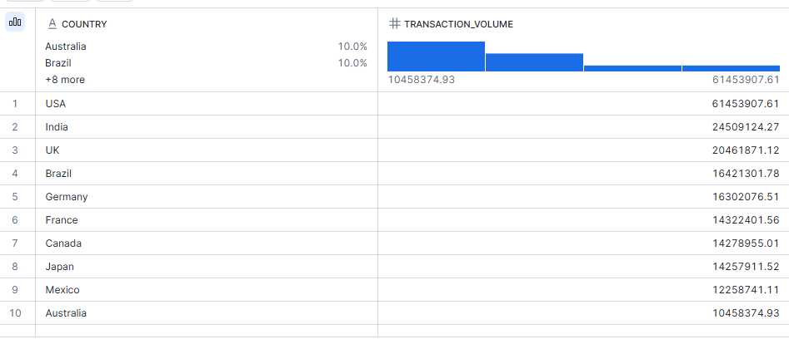
Q3. Find the top 10 cities generating the highest transaction value.
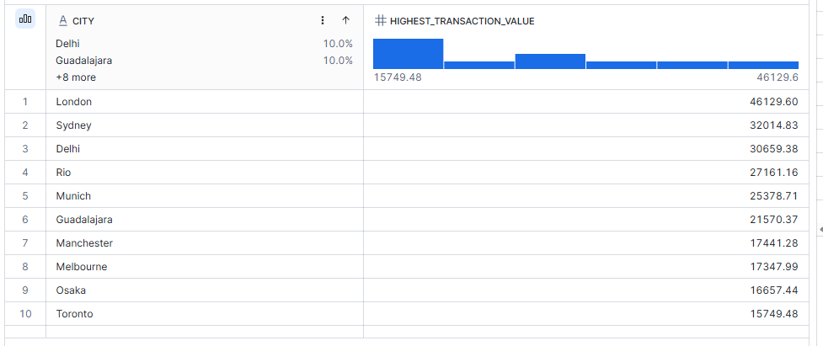
Q5. Determine the percentage distribution of transactions by:
- Payment Method
- 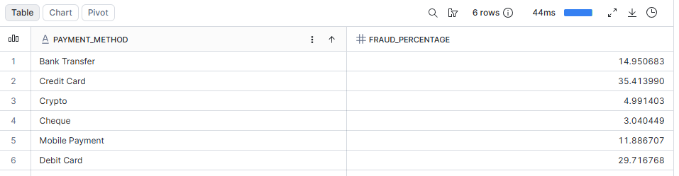
- Device Type
- 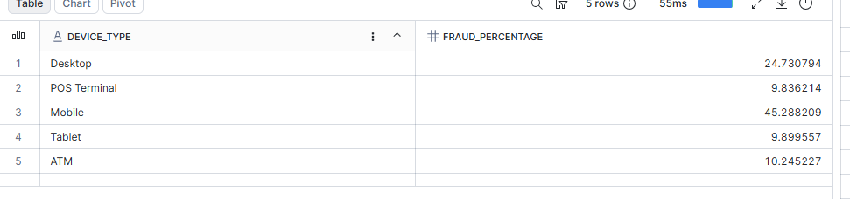
- Merchant Category
- 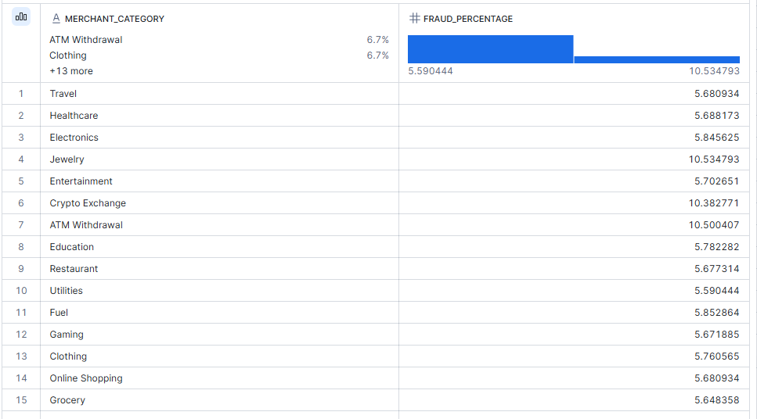
- Q6. Identify the top 20 customers by SUM(transaction_amount).
- 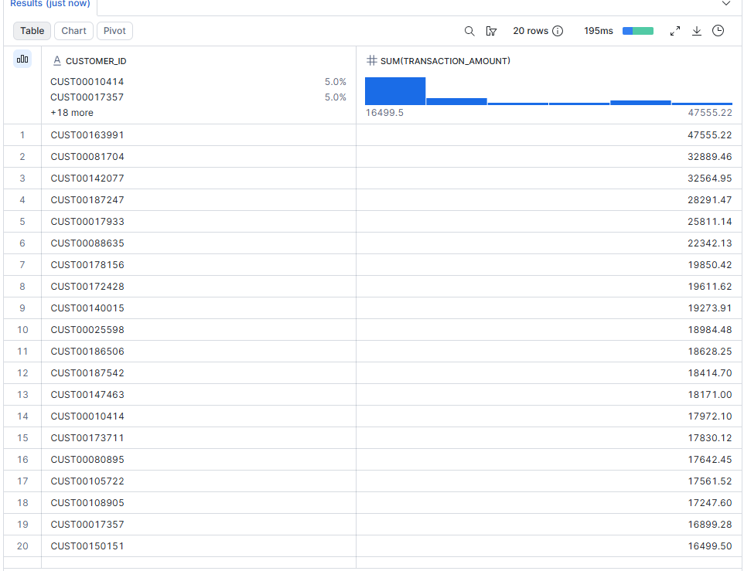
Q7. Calculate average transaction amount by age group:
- 18–25
- 26–35
- 36–50
- 51–65
- 65+
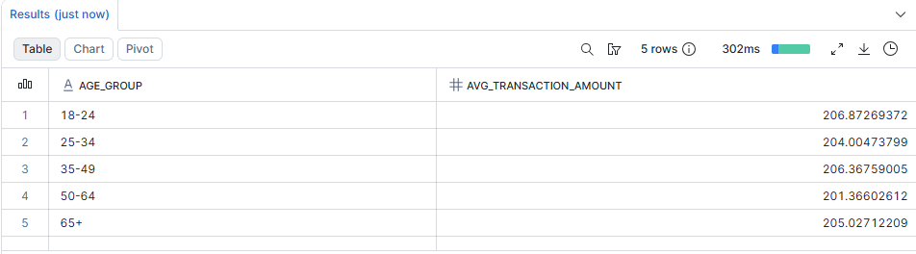
Q8. Determine which age group has the highest fraud rate.
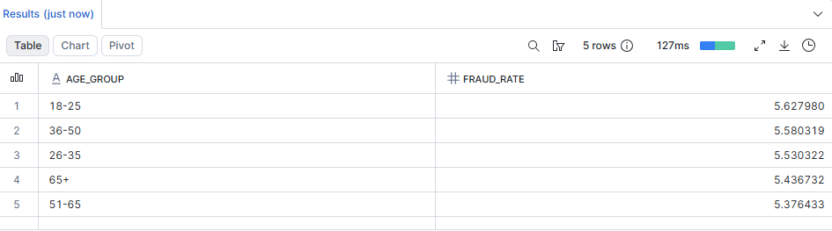

Q10. Calculate average account balance and credit score by country.
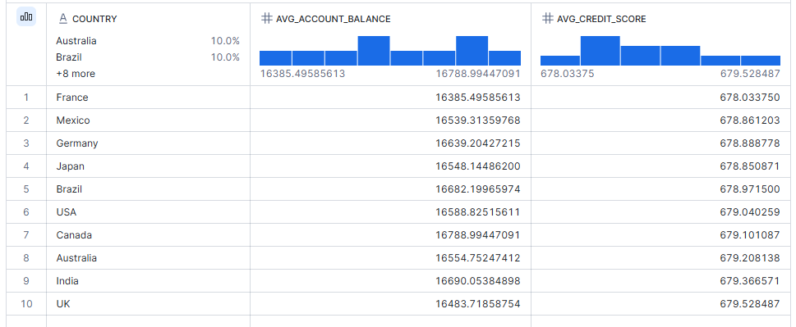
Q11. Calculate fraud rate by Merchant Category.
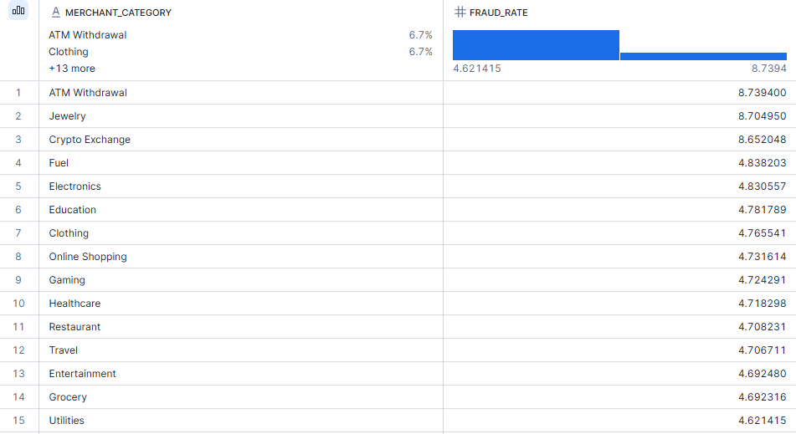
Q12. Determine fraud rate by Payment Method.
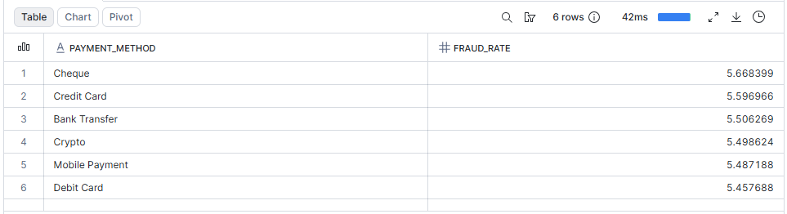
Q13. Determine fraud rate by Device Type.
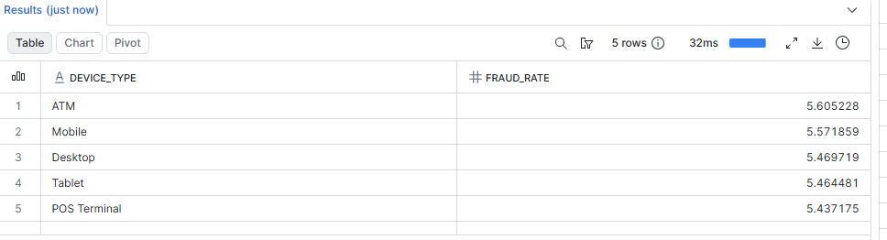
Q14. Find the most common fraud type. Output columns:
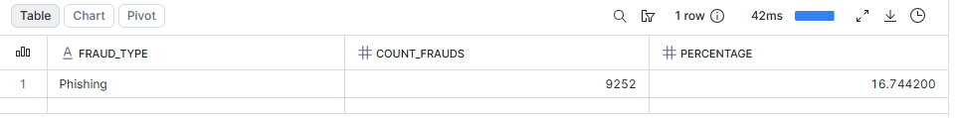
Q15. Analyze fraud transactions occurring during:
- Night vs. Day
- 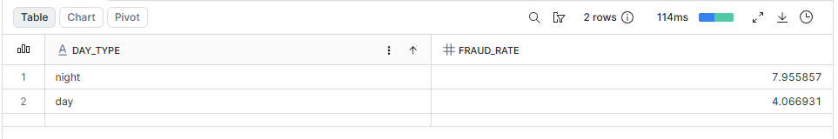
- Weekend vs. Weekday

Q16. Find transactions where transaction_amount exceeds:
AVG(transaction_amount) + 3 * STDDEV(transaction_amount)
Identify and report potential anomalies.
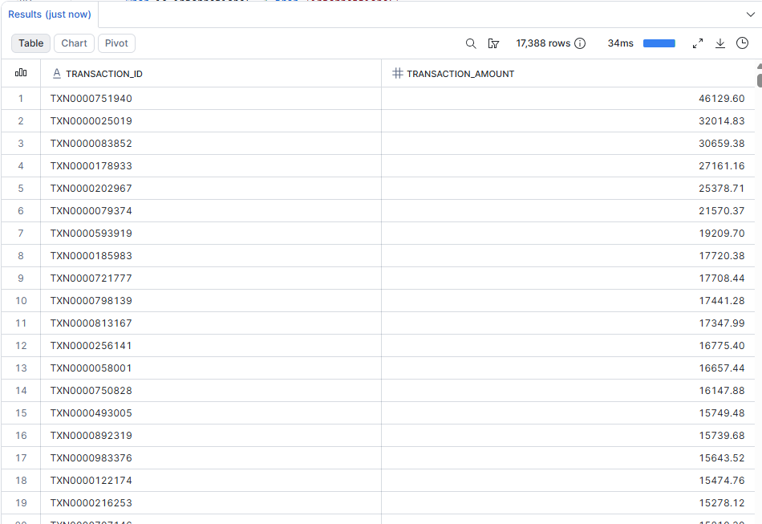
Q17. Identify customers having more than 3 failed attempts AND Fraud = 1.
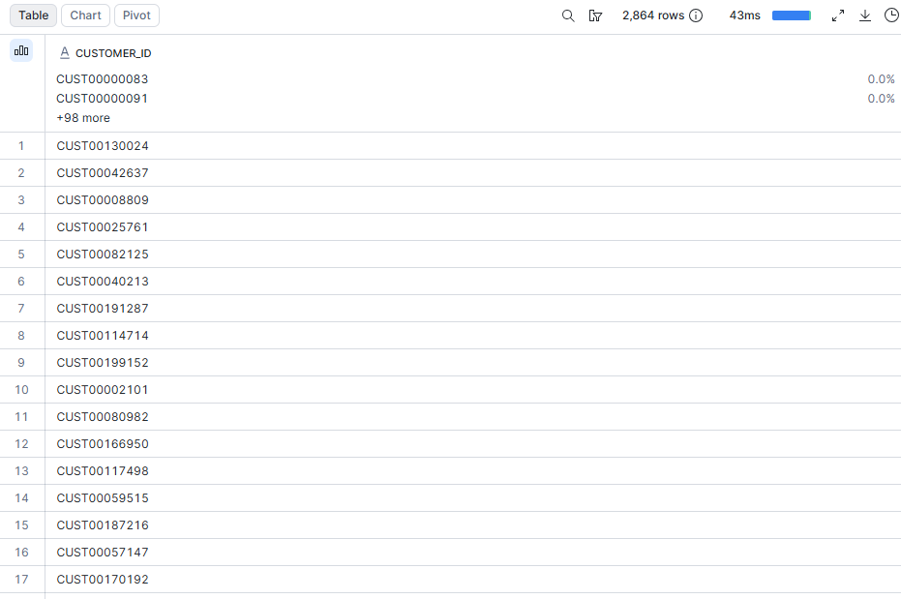

Q19. Analyze fraud rates for:
- International Transactions
- Domestic Transactions
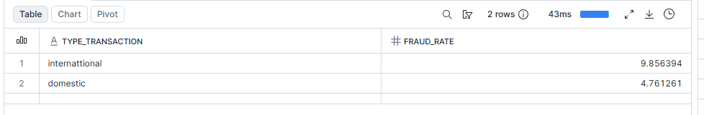
Q20. Find customers who performed all of the following, then rank by risk:
- International Transaction
- Night Transaction
- Failed Attempts > 2
- 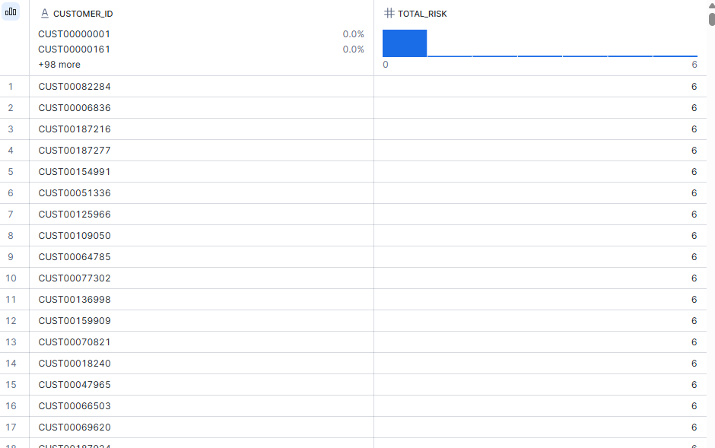
Q21. Rank customers by transaction value within each country.
Use: RANK()
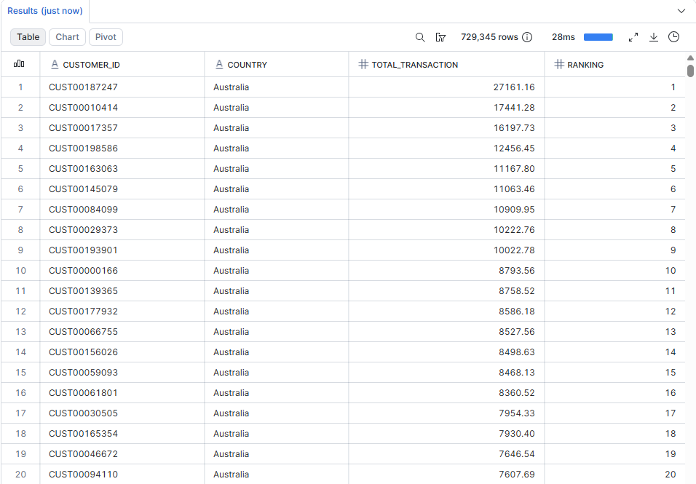
Q22. Find the top 5 highest-value transactions in every merchant category.
Use: ROW_NUMBER()
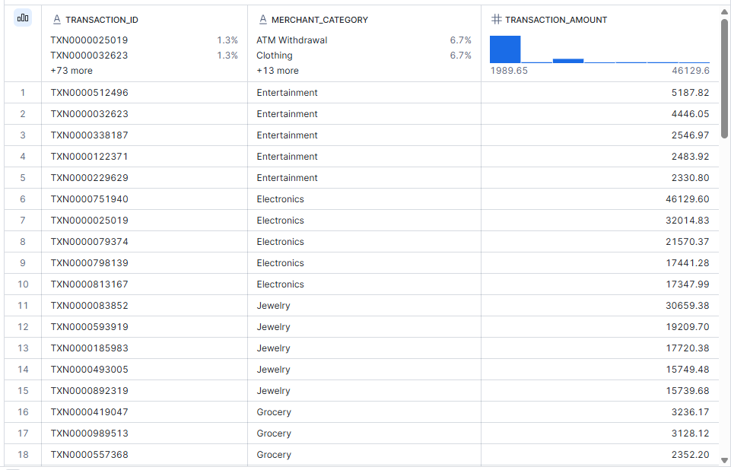
Q23. Calculate cumulative transaction amount per customer over time.
Use: SUM() OVER()
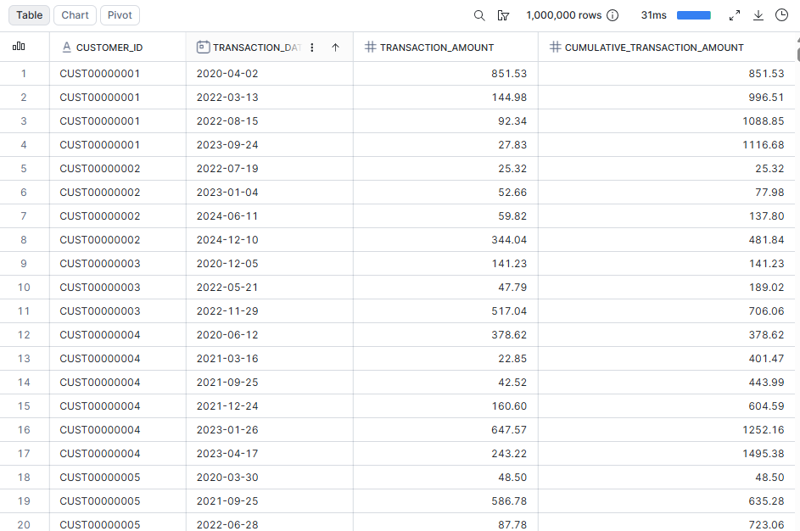
Q26. Create a View: VW_HIGH_RISK_TRANSACTIONS
Include records where:
- Transaction is International
- Transaction occurred at Night
- Failed Attempts > 2
- 